Project Exam 02
Patrick Ha
IS 257 S01 Big Data Analytics
Professor Wibbenmeyer
October 30, 2024

Project Exam 02
Part A - Step 1)
db.Customer.find().sort({lastname:1});
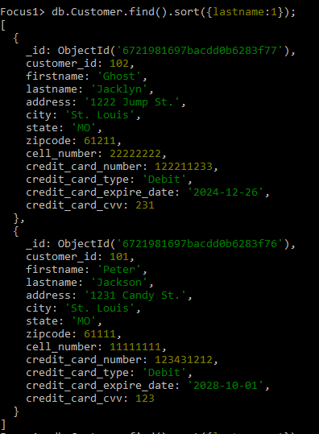
Part A - Step 2)
db.Customer.aggregate([
{
$group: {
_id: "$state",
count: { $sum: 1 }
}
},
{
$sort: { _id: 1 }
}
]);
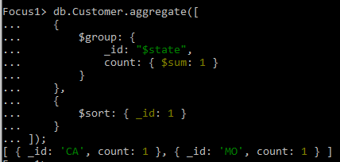
Part A - Step 3)
db.Products.find({});
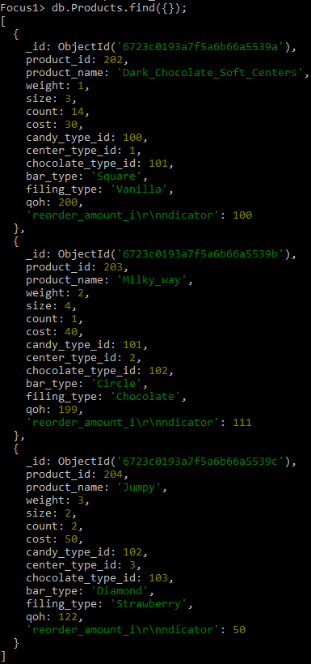

Part A - Step 4)
db.Customer.aggregate([
{
$group: {
_id: "$state",
Total_Customers: { $sum: 1 }
}
},
{
$sort: { _id: 1 }
},
{
$project: {
_id: 0,
State: "$_id",
Total_Customers: 1
}
}]);
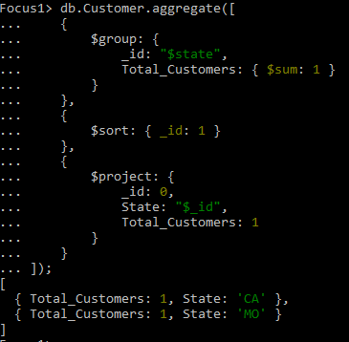

Part B Step 1:
[{
$unwind: {
path: '$order'
}
}, {
$unwind: {
path: '$order.order_items'
}
}, {
$facet: {
Monthly: [
{
$match: {
'order.order_date': {
$gt: ISODate('2022-10-06T00:00:00.000Z')
}
}
},
{
$group: {
_id: '$order.order_items.product_name',
total: {
$sum: '$order.order_items.count'
}
}
},
{
$sort: {
total: -1
}
},
{
$limit: 1
}
],
Quarterly: [
{
$match: {
'order.order_date': {
$gt: ISODate('2022-07-06T00:00:00.000Z')
}
}
},
{
$group: {
_id: '$order.order_items.product_name',
total: {
$sum: '$order.order_items.count'
}
}
},
{
$sort: {
total: -1
}
},
{
$limit: 1
}
],
Yearly: [
{
$match: {
'order.order_date': {
$gt: ISODate('2022-01-01T00:00:00.000Z')
}
}
},
{
$group: {
_id: '$order.order_items.product_name',
total: {
$sum: '$order.order_items.count'
}
}
},
{
$sort: {
total: -1
}
},
{
$limit: 1
}
]}}]
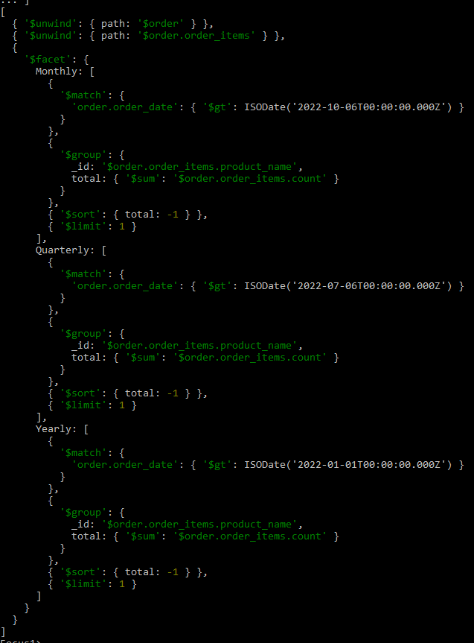
Part B step 1)
[{
$unwind: {
path: '$Order'
}
}, {
$unwind: {
path: '$Order_items'
}
}, {
$facet: {
Monthly: [
{
$match: {
'order.order_date': {
$gt: ISODate('2024-10-00T00:00:00.000Z')
}
}
},
{
$group: {
_id: '$Products.product_name',
total: {
$sum: '$Products.count'
}
}
},
{
$sort: {
total: -1
}
},
{
$limit: 1
}
],
Quarterly: [
{
$match: {
'Orders.order_date': {
$gt: ISODate('2024-10-06T00:00:00.000Z')
}
}
},
{
$group: {
_id: '$Products.product_name',
total: {
$sum: '$Products.count'
}
}
},
{
$sort: {
total: -1
}
},
{
$limit: 1
}
],
Yearly: [
{
$match: {
'Orders.order_date': {
$gt: ISODate('2024-10-01T00:00:00.000Z')
}
}
},
{
$group: {
_id: '$Products.product_name',
total: {
$sum: '$Products.count'
}
}
},
{
$sort: {
total: -1

Part B step 2)
[{
$unwind: {
path: '$Order'
}
}, {
$unwind: {
path: '$Order_items'
}
}, {
$facet: {
Monthly: [
{
$match: {
'order.order_date': {
$gt: ISODate('2024-10-00T00:00:00.000Z')
}
}
},
{
$group: {
_id: '$Products.product_name',
total: {
$sum: '$Products.count'
}
}
},
{
$sort: {
total: 1
}
},
{
$limit: 1
}
],
Quarterly: [
{
$match: {
'Orders.order_date': {
$gt: ISODate('2024-10-06T00:00:00.000Z')
}
}
},
{
$group: {
_id: '$Products.product_name',
total: {
$sum: '$Products.count'
}
}
},
{
$sort: {
total: 1
}
},
{
$limit: 1
}
],
Yearly: [
{
$match: {
'Orders.order_date': {
$gt: ISODate('2024-10-01T00:00:00.000Z')
}
}
},
{
$group: {
_id: '$Products.product_name',
total: {
$sum: '$Products.count'
}
}
},
{
$sort: {
total: 1

Part B step 3)
[{
$match: {
'Orders.order_date': {
$gte: { "order_date": { $gte: ISODate("2022-01-01T00:00:00Z"), $lt: ISODate("2022-07-01T00:00:00Z") }
}
}
}, {
$unwind: '$Order'
}, {
$unwind: '$Order_items'
}, {
$group: {
_id: '$Products.product_name',
total: {
$sum: '$Products.count'
},
revenue: {
$sum: {
$multiply: [
'$order.order_items.price',
'$Products.count'
]
}
}
}
}, {
$sort: {
revenue: -1
}
}, {
$limit: 3
}]

